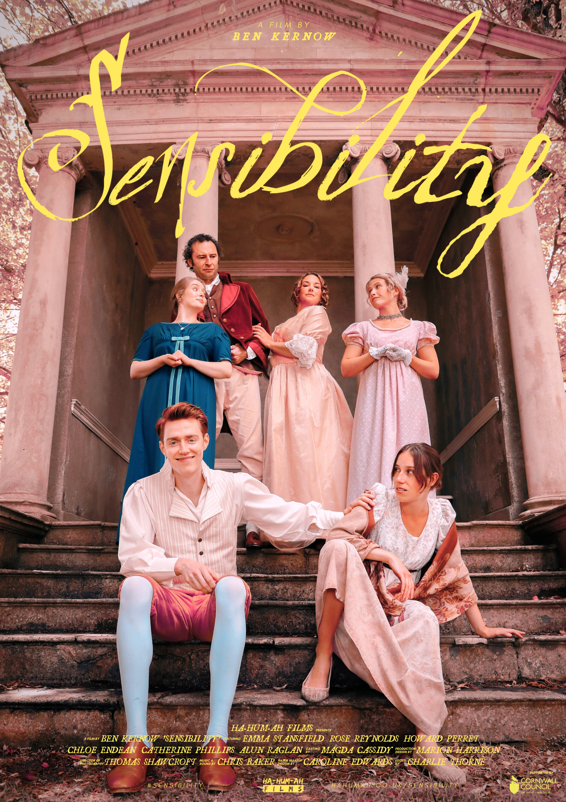

Sensibility
Logline:
High Society is a battleground. One must be willing to fight to maintain one’s place.

Synopsis:
The Howard's find themselves on the outskirts of London Society, however the unexpected arrival of a young eligible bachelor, and a Duke at that, offers the promises of a lifetime. The only thing standing in their way are themselves. Lady Howard must do battle with her cohort of un-married children if she is to stand any hope of capitalising on this once a season opportunity of bolstering the families standing within society.

Technical information:
Production Type: Short Film
Runtime: 14 minutes
Genre: Comedy
Completion Date: March 2022
Production Budget: £15,000
Language: English
Production Location: Cornwall
Format: QuickTime, Digital Cinema Package, MOV, MP4

Trailer: https://youtu.be/hg7nThROb7Q
Behind the scenes film: https://youtu.be/HxYGhoRRYNQ
Promotional & BTS Stills: https://drive.google.com/drive/folders/1oam1mGNRptcz9xG2GXWoCHeeje1v5U__?usp=sharing

Cast Biographies:
Emma Stansfield - Emma has been an actress and voice artist for over 20 years. She studied at the Central School of Speech and Drama. She is known for her TV work in shows such as ‘The Tudors’, ‘Endeavour’, Jimmy McGovern’s , ‘Accused’, and most recently, ‘The Salisbury Poisonings’, and has appeared in many theatre productions, including working at The National Theatre, Donmar Warehouse and in the West End.
A big fan of period dramas, Emma was delighted to get the role of Lady Howard in ‘Sensibility’, mainly because it allowed her to fulfil her ambition to waft about a stately home in a pretty frock, lauding it up as Lady of the Manor!

Rose Reynolds - Rose Reynolds was born in Devon, England. In 2009 she relocated to London to train at the Guildhall School of Music & Drama, graduating in 2012. She now considers home to be anywhere between Devon, London and Los Angeles. Film credits include A Grand Romantic Gesture (2019) and The World's End (2012). Notable television credits include Wasted (2016) Poldark (2016) and Crackanory (2016). Most recent work includes Alice in Wonderland/Tilly Jones in ABC's 'Once Upon A Time (2019).'

Howard Perret - Howard trained at ArtsEd where he received the Lilian Baylis award and was directed in Trevor Nunn's production of the Two Gentlemen of Verona. Since graduating, he has gone on to work at theatres such as the Old Vic, the Arcola, Richmond Theatre and Theatre Royal Bath. Earlier this year, he wrote & produced his first film, Paranormal Investigators, which will hopefully be making its way around the festival circuit later in the year.

Chloe Endean - Chloe is a Cornish actress and singer. Growing up with a background in movement and musical theatre she then made her way into screen and audio work as a teenager in Cornwall.
Film credits include: Long Way Back (2021), BAIT (2019). Theatre credits include: Twisted Tales (UK Tour - ‘Owdyado Theatre), The Illustrated Girl (The Asylum - Kneehigh), 13 The Musical (The Ambassadors).
Chloe is very grateful to be a part of such a lovely team and bring the Howard family to life.

Catherine Phillips - Originally from Bristol, Catherine studied drama at the University of Roehampton, before training as an actor at the Royal Central School of Speech and Drama. She has worked predominantly in theatre, with credits including Masha in Chekov’s The Seagull, and originating the role of Kaye Hamilton in Joshua Rosemblum and Joanne Lessner’s Stage Door.
Additionally, Catherine is a founder and producer for theatre company Make Bloom, and a regular session vocalist working with artists and producers in London.
Sensibility marks Catherine’s film debut and she is thrilled to be a part of the crazy Howard family!

Alun Raglan - Alun was born in Wales, and trained at Bristol Old Vic and GITIS, Moscow. He began in theatre with a season at Theatr Clwyd with Terry Hands instead of taking a General Motors ad for America that would have paid off all the debts..... Arse!
His first film role was in Ridley Scott's Gladiator. Since then his work has encompassed both TV, Film and Theatre, with screen work including Netflix's Cursed & The Worst Witch, along with Baptiste, Thirteen, Death in Paradise and Holby City for the BBC.

Emerson Pike - Emerson has worked on stage for over ten years, some of his recent roles include Orlando in 'As You Like It', Bottom and Demetrius in 'A Midsummer Night's Dream' and Victor Frankenstein in 'Frankenstein'. A big fan of lying down, Emerson was very happy to play the part of the Duke of Bedford and be dragged down hills and splayed across a chaise lounge

Jenny Beare - Jenny grew up in Padstow where she divided her time between practising the dramatic arts and following the Blue Oss, accordion in hand. After working on ‘Hells Mouth’ by Nick Darke and the RSC whilst still at college, she studied performing arts in Stratford Upon Avon. Since returning she has told stories at Eden and performed with Kneehigh Theatre (Fup/Dancing Frog at the Asylum) and various Cornish theatre companies including; Kernow King (Pasty Man & Pastry Maid, Cornish Caretakers), Minack Theatre (Secret Garden, Goodnight Mister Tom), O-Region, Wildworks, Rogue Theatre, Trebiggan, Golden Tree and Light Theatre. Film credits include Happy Christmas directed by Mark Jenkin, Tamara (Cornish language film) directed by Will Coleman. Jenny is thrilled to be part of this film.

Directors Statement:
It is safe to say that Sensibility isn’t your average short film for a first-time filmmaker. Many would argue that a period drama with elaborate costumes, locations and numerous characters possibly isn’t the obvious choice for one’s first dive into filmmaking. However it oddly felt like the right choice!
I have always been drawn by stories which have an epic or larger than life quality to them. I also can’t hide that I’m a big history geek and delving into a historical setting not only offers huge scope for play and story development as a storyteller, but also makes me feel like a kid in a sweet shop. For me that ability to transport an audience to another world or period in time is an exciting one. I also find that these explorations often give us an insight or a new understanding of our own world and time.
Sensibility was filmed entirely on location in Cornwall using a predominantly Cornwall and South West based creative team. Indeed I couldn’t imagine anywhere else to make this film, although I admit being a Cornishman makes me very biased!
Sensibility is as much an exploration of a genre as anything else. The period drama and in particular the regency love story have become firm favourites in popular culture. Mention the works of Jane Austen and there are few who have not heard of them. Their stories of courtship, social standing and victory through hardship resonate just as strongly now as they did over 200 years ago. Through this film I wanted to dissect this idea we have of the regency period and its archetypal stories of courtship and status.
Through the lens of a rather dysfunctional family, Sensibility explores a period in time and the people that inhabited it with a vibrancy and playfulness. Such an ambitious project of course wouldn’t have been achievable without a phenomenal team of creatives. I’m beyond thankful to every single one of them in helping to bring this story to the screen.

Crew Biographies:
Ben Kernow - Hailing from North Cornwall, Ben trained as an actor at the Academy of Live and Recorded Arts (ALRA) and has worked on both the stage and screen ever since.
In 2018 he formed Ha-Hum-Ah Theatre and began developing his own body of work as both a producer, director and writer. Work for the company has included Moira Buffini's satirical 'Loveplay' in co-production with the Minack Theatre, along with co-productions of 'A Dickensian Christmas', 'Oh No It isn't!' and 'Finnegan & Tweed' with intoBodmin.
2021 saw Ha-Hum-Ah expand into the world of film with the creation of Ha-Hum-Ah Films. Sensibility marks Ben's film directorial debut.

Thomas Shawcroft - Thomas Shawcroft is a DOP from the south west, UK. He worked his way up through working on Period Drama's over the years, such as Poldark and Wolf Hall for the BBC and Galavant for ABC. Work as a DOP has included the award winning short Transmission which was shot entirely on 35mm film as well as Rose Pandemic starring Patricia Hodge.
He has a strong connection with the North coast of Cornwall, after many years spent surfing close to Bude. He really enjoyed the creative process and collaborating with Ben to organically find the core feel to Sensibility and have that guide the lighting and framing of the film.
He also enjoys sweet based bakery goods on the weekend. Pain Au Raisin in particular!

Marion Harrison - Marion has worked in the theatre and film industry since graduating from Leeds University in 2002 with a BA Hons in Theatre Design & Technology. After spending many years as a Touring Wardrobe Manager for companies such as the R.S.C, National Theatre, Headlong and The National Theatre of Scotland, Marion settled in Cornwall and has moved into the role of freelance Costume/Production designer.
Marion has been involved with many projects and productions across the county, designing and producing costumes for The Man Engine (Golden Tree Productions), Orfeo and The Wolves of Willoughby Chase for The Minack Theatre, A Dickensian Christmas and Loveplay for Ha-Hum-Ah Theatre and a variety of sets and costumes for the Eden Project, including Room On the Broom, Mrs Christmas, Chocolate Unwrapped, Festival of Food and The Green fingers Festival.

Charlie Thorne - Charlie is a freelance editor and assistant editor who has worked across feature films such as Emma, Yesterday, My Cousin Rachel and recently Romeo & Juliet in collaboration with the National Theatre as well as a myriad of short films. His affection for detailed and honest, intimate approaches combined with a technical expertise support his expanding portfolio of work.

Chris Baker - Chris has worked on both commercial and film projects worldwide; with compositions performed by a variety of ensembles, and work recently being showcased on BBC Radio 6. An enthusiastic and active post-modern composer and sound engineer, with a rapidly growing portfolio of work that showcases both hybridity and artistic innovation.
Musical projects span over an array of award winning short films and commercials, whilst his latest sound engineering projects include work for the G7 Summit and BuzzFeed. Chris is a multi-instrumentalist, with a refined sonic sensitivity, offering a comprehensive understanding of both sound and music.

Magda Cassidy - Magda Cassidy (she/her) is a Casting Director, musician and creative practitioner from Devon. She trained as an actor and holds an MA in Musical Theatre (Royal Central School of Speech and Drama) and BA in Drama (The University of Exeter). Over the last few years she has worked with Casting Directors in the UK, Ireland and Australia on a variety of television and animation projects.
Her credits include BAFTA winning series 'The Dumping Ground', 'JoJo & Gran Gran', 'My Mum Tracy Beaker’, and 'Mama K's Team 4'. She is currently working on a major new series for AMC. Magda is passionate about working with actors and singers, offering casting workshops and audition coaching, incorporating meditation, breathing and yoga techniques. She has two Siamese cats, although she identifies as a dog-person.

Credits:
Emma Stansfield - Lady Howard
Rose Reynolds - Elizabeth Howard
Howard Perret - Edward Howard
Chloe Endean - Jane Howard
Catherine Phillips - Mary Howard
Alun Raglan - Lord Howard
Jenny Beare - Servant
Emerson Pike - Duke of Bedford

Ben Kernow - Director / Writer / Producer
Thomas Shawcroft - Director of Photography
Marion Harrison - Production Designer
Charlie Thorne - Editor
Chris Baker - Composer / Sound Recordist/Mixer
Magda Cassidy - Casting Director
Jonny Dry - 1st Assistant Director
Leonardo Donadio - 2nd Assistant Director
Andrea Clavijo - 1st Assistant Camera / Focus Puller
Andrew Brierley - 2nd Assistant Camera
Leon Laza - Gaffer
Adam Pemberton - Electrician
Hana Backland - BTS Photography
Caroline Edwards - Hair & Makeup Designer
Lucie Allano - Hair & Makeup Artist
Yasmin Baird - Art Department Assistant
Ollie Andersen - Colourist
Mark Maltby - Online Editor
Barbora Bodláková - Musician
Zoë Curnow – Musician

Press Contacts:
copies of images and videos can be emailed in various formats upon request.
All press inquiries should be made to the below contact details.

Ben Kernow
info@hahumah.co.uk
+44 (0) 7772 881 893

Instagram: @hahumah_
Twitter: @hahumah_
Facebook: @hahumahcornwall
#sensibility

